**Resource Histogram for NutriScope**

**Prepared by: Team Task Titans** **Date: 16th April 2024**

**Table 1: Number of Employees Needed for Testing Each Week**

|  |  |  |  |  |  |  |
| --- | --- | --- | --- | --- | --- | --- |
| **Time**  **Roles** | **Week 1** | **Week 2** | **Week 3** | **Week 4** | **Week 5** | **Week 6** |
| **Consulting Firm Senior Tester** | 1 | 1 | 1 | 1 | 1 | 1 |
| **Consulting Firm Junior Tester** | 0 | 0 | 2 | 2 | 2 | 2 |
| **User Group Manager** | 0 | 0 | 0 | 0 | 2 | 2 |
| **User Group Worker** | 2 | 0 | 0 | 4 | 4 | 4 |
|  |  |  |  |  |  |  |
| **Total** | 3 | 1 | 3 | 7 | 9 | 9 |

Based on Table 1 above, a resource histogram for NutriScope was created as follows:

**Figure 1: NutriScope Resource Histogram for Testing**

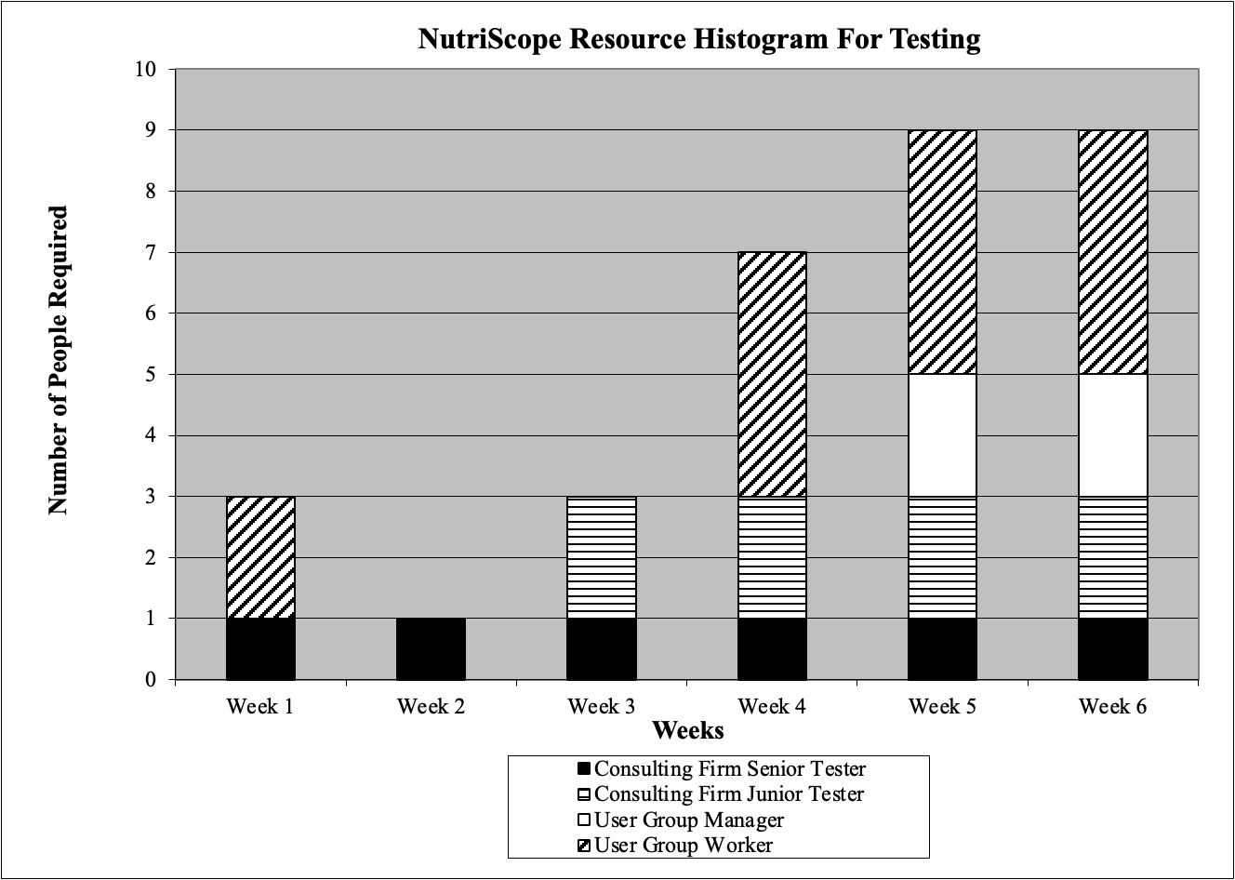

The chart displays the number of people required from each personnel type (pattern-coded) per week for testing. One senior tester is needed for all six weeks, two junior testers are needed for the last four weeks, two user group workers are needed for the first week, four user group workers are needed for the last three weeks, and two user group managers are needed for the last two weeks.